Q1. You have $100,000 to invest, and the Annual Percentage Rate is 12%.

Which of the following compounding frequency will give you the highest future value?

A) Compounded annually FV = 100000*(1+0.12/1)^1 = 112000

B) Compounded monthly FV = 100000*(1+0.12/12)^12 = 112683

C) Compounded weekly FV = 100000*(1+0.12/52)^52 = 112734

D) Compounded daily FV = 100000*(1+0.12/365)^365 = 112747

Q2. The U.S. government is trying to borrow a large sum of money from investors today. It promises to make a payment of $847 every year forever, and the first payment starts three years from today. If the interest rate is 10% per year (compounded annually), what is the present value of the payments?

PV2 = 847/0.1 = 8470

PV0 = 8470/1.1^2 = 7000

Q3. Suppose that you can afford to pay an installment payment of $236 per month over the next 36 months to buy a car and you can borrow at an interest rate of 1% per month. (Installment payment is paying at the end of each month.) How much interest expense would you incur at the end of the second month? Round it to a whole number.

PV = 236/0.01*(1-1/1.01^36) = 7105.37

|  |  |  |  |  |
| --- | --- | --- | --- | --- |
| Month | Installment Payment | Interest Expense | Principal Payment | Ending Balance |
|  |  |  |  | 7105.37 |
| 1 | 236.00 | 71.05 | 164.95 | 6940.42 |
| 2 | 236.00 | 69.40 | 166.60 | 6773.83 |

Interest Expense = $69

Q4. Company ABC has just made a dividend payment of $0.1 per share. If the dividend is expected to grow at 5% per year, and the discount rate is 10% per year, what should be the stock price?

A) 2

B) 2.1

C) 20

D) 21

The first dividend to be paid in the future is 0.1*(1.05), NOT 0.1

Price = 0.1*(1.05)/(0.1-0.05) = 2.1

Q5. The price of a 10-year coupon bond that has a face value of $1000 and pays coupons at the rate of 5% annually has a current price of $1085.30. Find the yield-to-maturity of this bond. Write your answer in decimal form up to two decimal places. (For instance, if you think the answer is 4.233%, write it as 0.04)

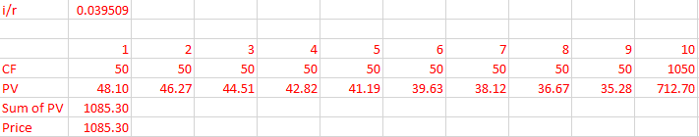

YTM = 0.04